Erik the Flutemaker Ministries Update
March 17, 2017

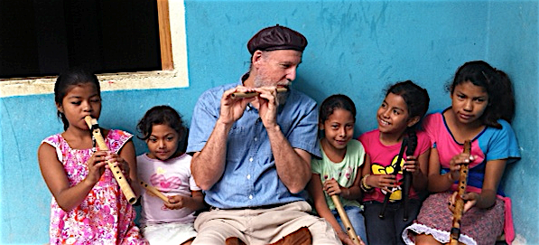
Well, God bless you, Heartdwellers. I wanted to tell you, too, that Erik Sampson of Erik the Flutemaker Ministries has taken care of several families that he has received funds for families 1, 2 and 3. Latrine holes are dug and three teams are ready to finish projects before the rains of late May. That's beautiful. We're talking about roofs, latrines, furniture, medicine, food...many, many needs have been met.

So, we're doing very well there.

I would like to ask a favor of you. Please, if you're going to donate to them, please donate to them directly, when it's appropriate. I also wanted to let you know that we have made several substantial donations to them. So, they're doing quite well. And I think at this point, it's good to keep them in mind, whenever you have extra or every month, if possible. That indeed will keep the needs being met.

So, I just wanted to give you a head's-up on that, dear ones. If you do want to make a donation, please do make it directly to Erik and mention that you are from Heartdwellers.

And thank you for continuing to support us. We really, really appreciate that. We have two new people on board, because the amount of work and volume of work that we have is getting much more intense. And I need more help. So, we've got two more people that are involved in the ministry now and working full-time. So, we very much appreciate your donations. It helps to take care of them.

And we're planning also on being able to distribute books and CD's in the not too distant future, right out here from our home, for free. Freely we've been given and we've received, so we give freely.

The Lord bless you all. You're greatly loved and appreciated. Your letters to me are wonderful. I read them to Ezekiel and to our staff, and they're very, very touched by your letters. Thank you so much.

And forgive me if I haven't answered. We have truly been overwhelmed with wonderful things over here.

